Effective: 06.29.2020

Plan for limited access to facilities at: LAURA S. WALKER STATE PARK

To meet Governor Kemps Executive Order regarding COVID-19 and in addition to the State Parks and Historic Sites Operational Plan for all sites, the following procedures are being implemented:

- Site will only allow up to, but no more than, the number of visitors listed below inside the following facilities:
  - Interpretive Center: 8 guests at a time.
  - Park Office & Trading Post: 2 guests at a time
  - Club House: 6 guests at a time

- Site staff will use the following methods to limit capacity to these facilities:
  - Staff will advise guests to stand on the social distancing mark until the front counter is available for them at the office and the pro shop.
  - Guest will be provided laminated Visitor Passes to use for entry into the facilities and are as follows: 8 at interpretive center, 2 at park office and 6 at the club house.
  - A sign will be placed on the door to advise guests to Please wait outside if there are two guests inside, until a guest exits.
  - Taped lines outside the park office, pro shop and interpretive center to maintain social distancing of our guests waiting on an entry pass.

- Other methods taken to accommodate limited access, while protecting staff and our visitors, and ensure social distancing guidelines are followed:
  - We will use floor signs to prevent the guest from getting too close to the front counter at the pro shop and park office.
  - A sneeze/cough shield will be placed at the front counter to prevent contamination with our guests and or staff.
  - Hand sanitizer on counter.

Interpretive Center:
Guests will be allowed into the interpretive center up to 8 at one time, they must stand in the spots placed on the floor. Guests will be encouraged to use hand sanitizer upon entering the building. Interpretive staff member will not allow more than 8 persons at any given time to be present inside of the building. Guests will not touch or use any programming equipment at the interpretive center until new guidance has been presented. It is expected that children especially will touch the aquariums and tables, employees will frequently disinfect the tables and outside of the aquariums using sanitizer and disinfectant spray per our current cleaning guidelines. There is no area for any sneeze/cough shields, therefore social distancing in this area is paramount and expected compliance by guests and staff that are inside of this facility. On a Monday-Thursday basis beginning June 29th.

Park Office:
Guests will be allowed into the park office 2 at a time, other guests will be asked to wait outside until another guest leaves. Staff will also monitor to ask other guests to please wait outside if they do not see the sign in time and wait until a spot inside becomes available. Credit card swipe is already on the counter for the guests. We will need to disinfect the office more frequently after our guests exit. We will ask guests to please use their own hand sanitizer prior to conducting business at our front counter or ours if they do not have their own available. This will aid in keeping our front counters less susceptible to contamination. On a Monday-Thursday basis beginning on June 29th.

Discontinue allowing guests to try on caps or shirts due to possible contamination from the virus by contact with items.

Pro Shop:
Have everyone enter the building from the parking lot side and exit on the golf course side. Allow no more than 6 guests in the building at one time. Place a sign on the floor every 6 feet starting at the door. Staff will also monitor to ask other guests to please wait outside if they do not see the sign in time and wait until a spot inside becomes available. Attach credit card swiper on the counter where customers can swipe the card themselves. We will need to disinfect the office more frequently after our guests exit. Continue one person per cart unless they ride in vehicle together or are immediate family. We will need to disinfect the pro shop more frequently due to COVID-19 after guests exit. We will also need to do so with our bathrooms on the inside of the pro shop as well. We will ask guests to please use their own hand sanitizer prior to conducting business at our front counter or ours if they do not have their own available. This will aid in keeping our front counters less susceptible to contamination. On a Monday-Thursday basis beginning on June 29th.

Discontinue allowing golfers to try on golf gloves, caps or shirts due to possible contamination from the virus by contact with items. If they purchase, refunds due to COVID-19 current guidelines.

Rental Equipment:
We currently request that we do not rent kayaks, aqua cycles, or bikes until further notice due to COVID-19. We do not have enough staff to keep equipment and pfd’s clean after each guest. If we order more pfd’s in July, we may be able to allow the 72 hours for the items to decontaminate between guests.

Cabins:
We will continue to place one day closure on the cabin between guests to sanitize and protect both guests and staff from COVID-19.

Campground:
With only one host in the campground at this time, we request to keep one comfort station closed until we have two hosts on site.

Square Footage of Buildings:
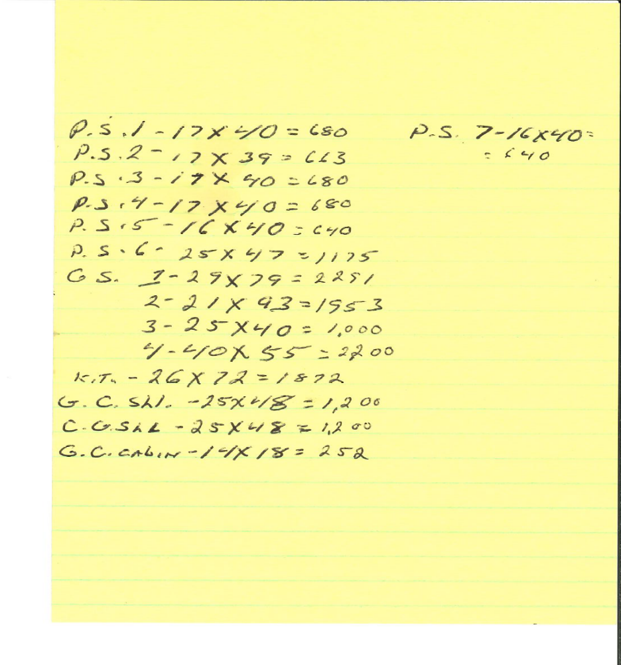

Picnic Shelters:
Picnic Shelters 1, 2, 3, 4, 5, 6, 7 may have 20 guests provided they maintain 6’ social distancing.

Group Shelters:
Group Shelters 1, 2, 3, 4, and Group Camp Kitchen are all more than 1,000 square feet and will allow 25 guests provided they maintain 6’ social distancing.

Group Camp Cabins:
The group camp cabins are only 252 square feet, therefore it will only allow the same family per unit, if it is a group, since there are 8 bunks in each of the 16 cabins.

Prior to opening:
Sneeze/Cough shields in place, hand sanitizer stations set up and meet with staff that will be operating the clerk positions and their managers to make sure each person understands and remains compliant with our limited access plan for our facilities.

